Leandro Deagueros

11/28/2021

Database Project Assignment 7: Web Connectivity

Connect your database to a web application. You can use ROR, PHP, Flask, NodeJS, .NET, Django, Struts, or whatever else you’d like to use to exhibit your skills.

Explain the process of connecting your database to the web by creating documentation. Include detailed explanations and screenshots!

To fully submit this assignment for grading, demo your work on Flipgrid.

I connected to the database using NodeJS. I made a MySQL connection that connects the host to localhost, and to my database ASZ. Then I had to verify the connection by throwing an error if it does not connect.

I made a query that connects to the player table in my ASZ database. Throws error if not found.

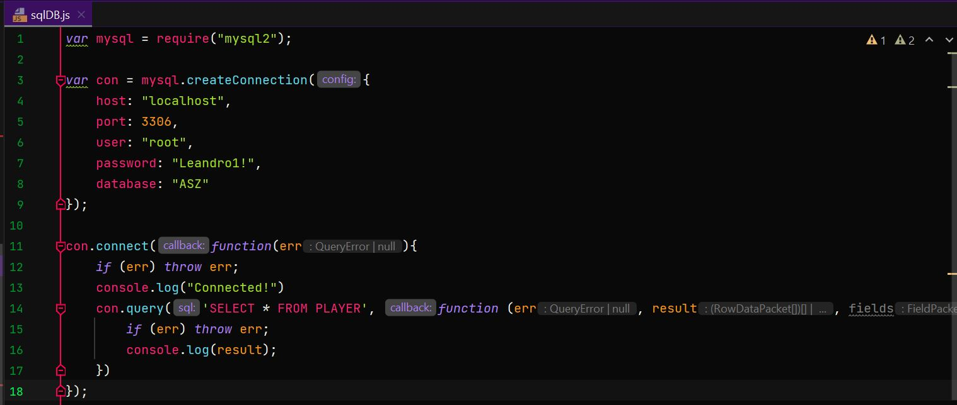



Output after I ran the code. Displays ASZ database with the player table.

